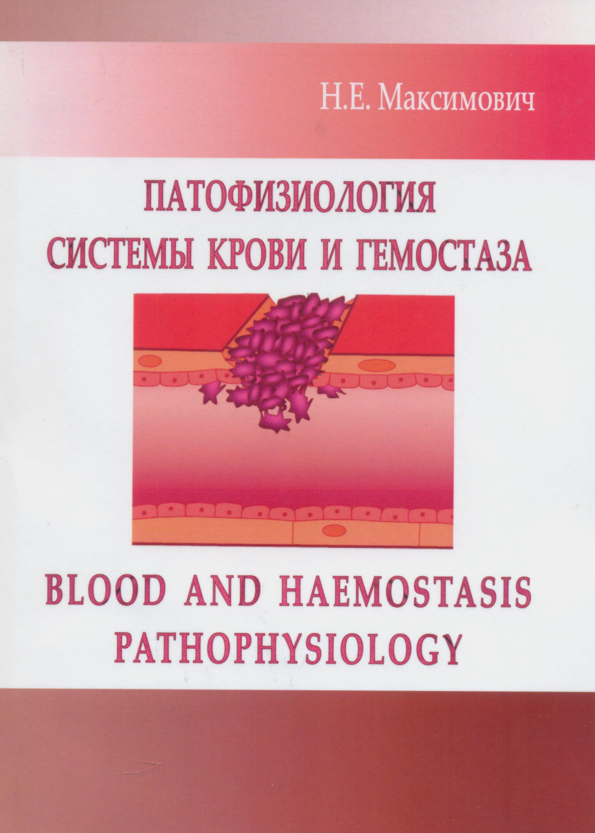
Manual «Blood and haemostasis pathophysiology» is intended to the Faculty for Foreign Students taught in English for successful studying the subject. It contains the information on the topics of the part of Pathophysiology «Blood and haemoslasis pathophysiology».

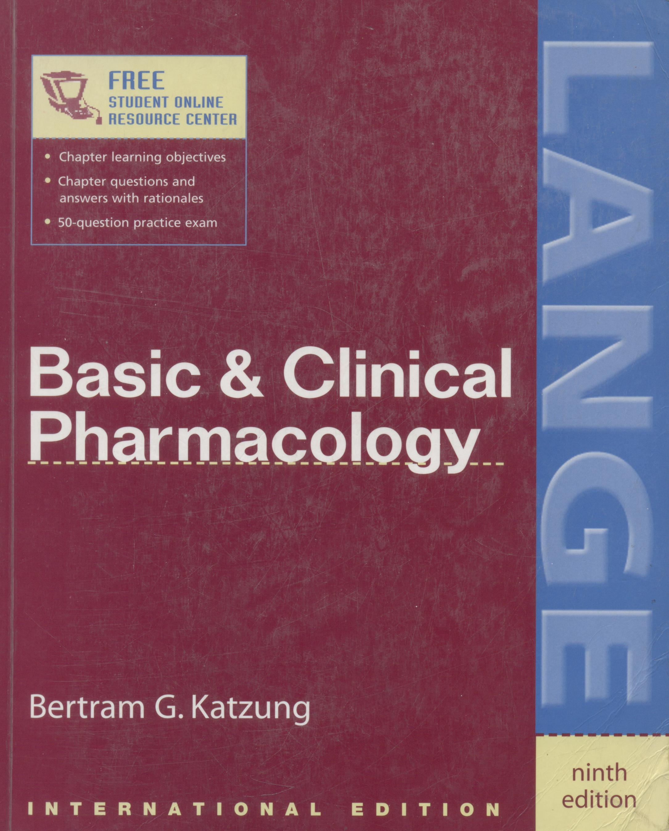
RECOGNIZED AS THE LEADING PHARMACOLOGY TEXT AMONG
STUDENTS AND PROFESSIONALS, BASIC & CLINICAL PHARMACOLOGY
OFFERS AN UNPARALLELED UNDERSTANDING OF BASIC PHARMACOLOGIC PRINCIPLES AND CLINICAL USE OF DRUGS.
- Authoritative, readable presentation of the scientific basis of pharmacology and its implications in clinical drug therapy
- Organized by drug groups and prototypes
- Rigorously updated throughout, including coverage of antiarrhythmic drugs, antidiabetic drugs, anthelmintics, antiviral drugs, and drugs used for gastrointestinal conditions
- New focus on important developments in pharmacology based on genetically modified mice ("knockout" and "knockin" mice)
- Mechanism of action and toxicities of traditional and newer drugs
- Treatment strategies and drugs of choice for all major diseases
- Numerous reader-friendly features such as special interest boxes, list of common preparations, and dosage information
- Unique, evidence-based chapters on drugs of abuse, special aspects of perinatal, pediatric, and geriatric pharmacology, and herbal medications and nutritional supplements
More than 500 illustrations and tables

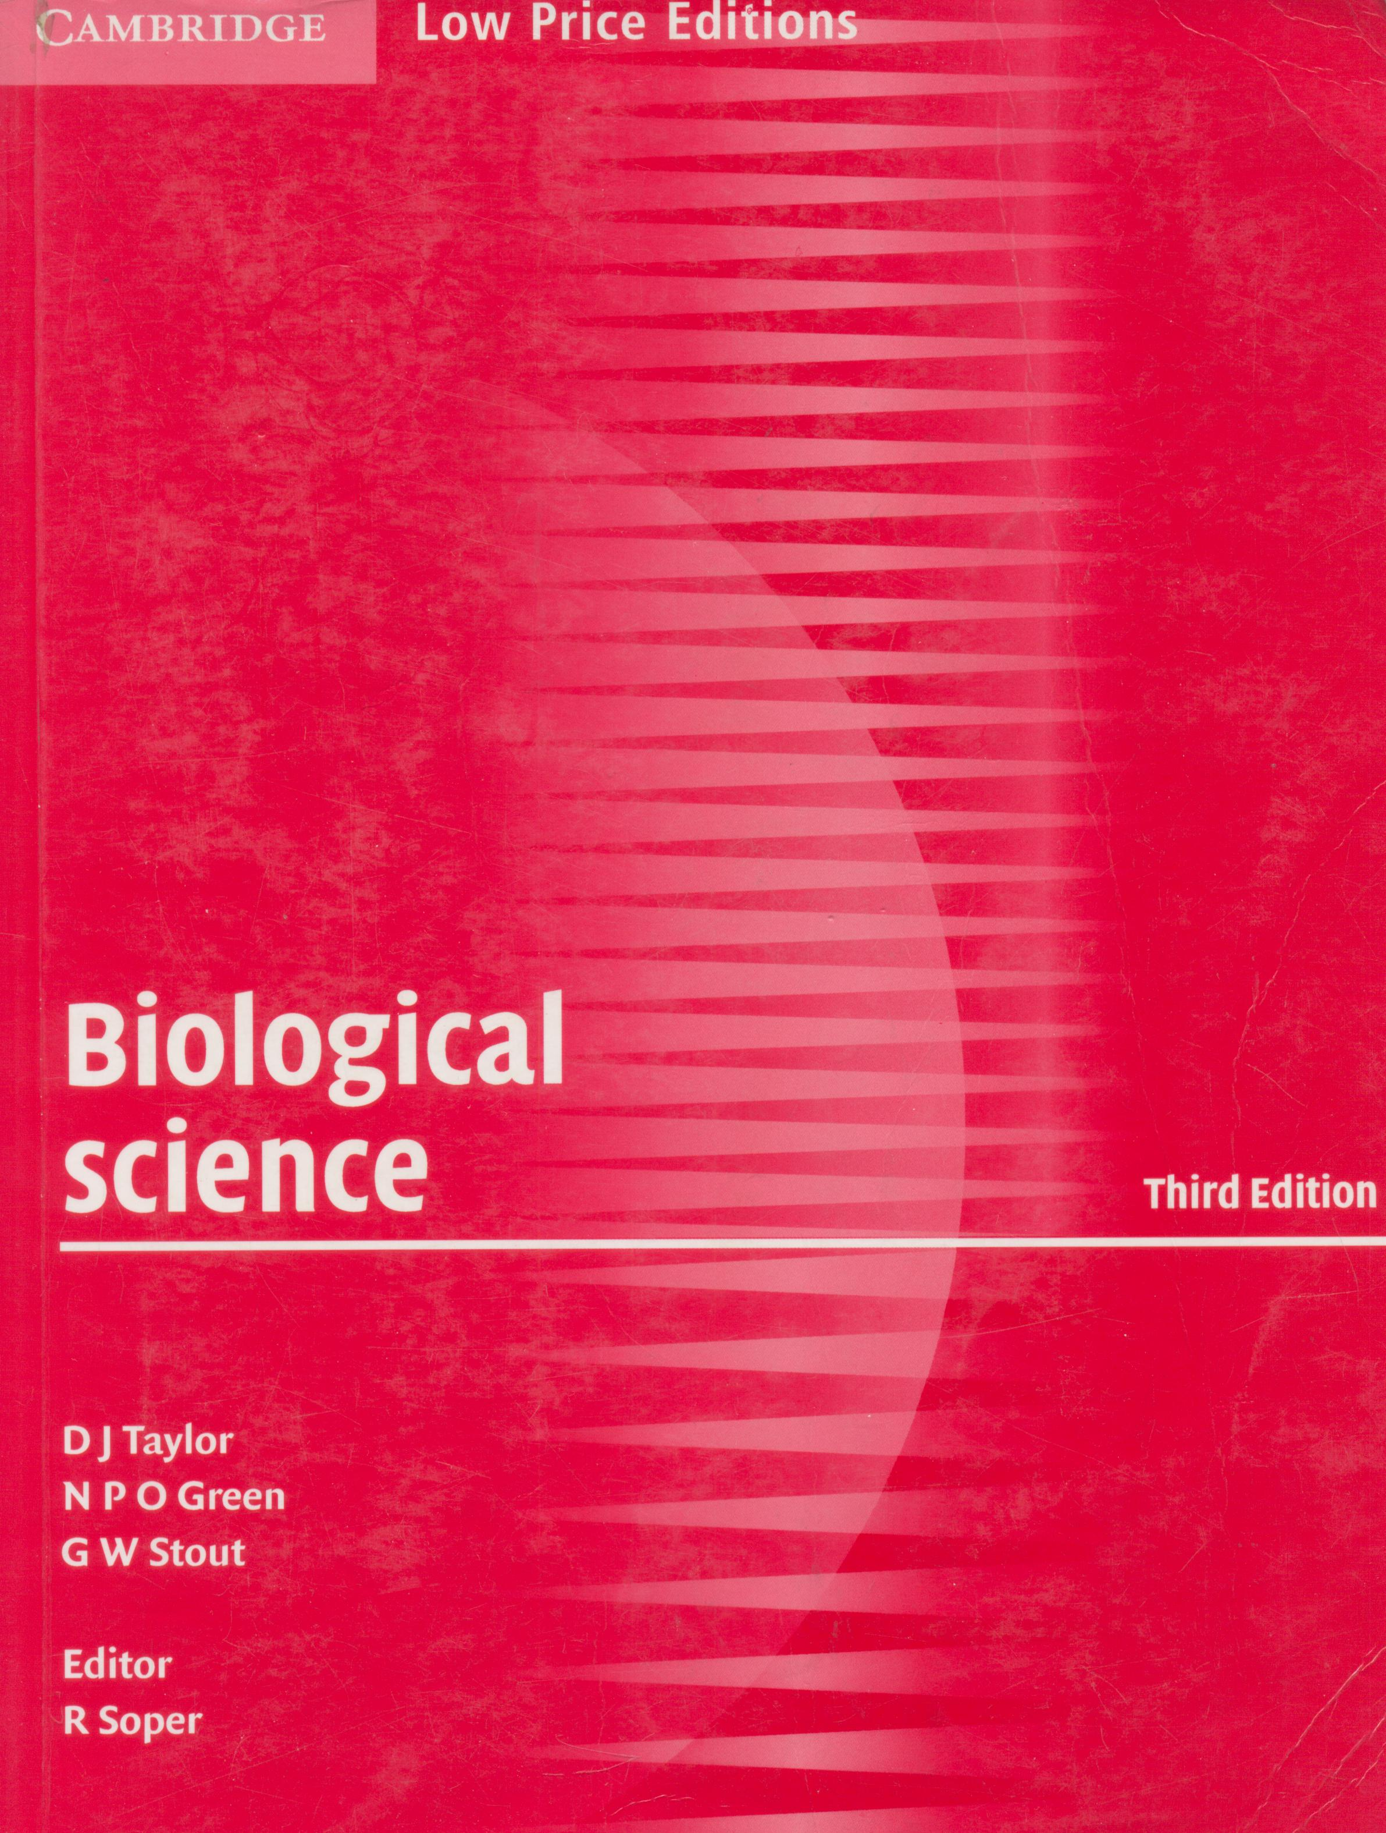
This is the new edition of the highly successful textbook Biological Science, a comprehensive and internationally established text for advanced students, including those following undergraduate courses. The text has been revised and updated, and provides comprehensive coverage of all the major areas of the biological sciences. New material has been added in the following fast-moving areas: human health and disease, microbiology and biotechnology, and the applications of genetics. Thought-provoking questions permeate the text to stimulate an enquiry approach to the subject, with answers in a commentary at the end of the book. In addition, a number of useful appendices are included covering biological chemistry, biological techniques and statistics. All the essential laboratory work required at this level is included in the form of selected and clearly presented practical investigations.

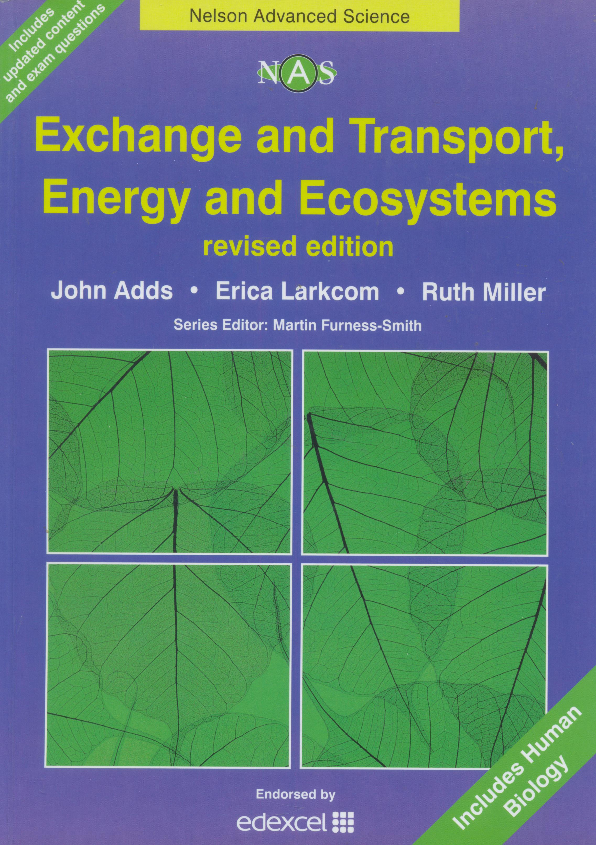
Nelson Advanced Science: Biology is a series of stimulating, high-quality, books for Advanced Subsidiary (AS) and Advanced (A) GCE Biology and Human Biology. Written by Senior Examiners and those involved closely with the AS and A GCE specification and its assessment, the books will help you achieve real success during your studies.
Exchange and Transport, Energy and Ecosystems revised edition gives thorough coverage of Units Two and Three of the Edexcel specification, offering:
- An accessible and clear layout
- Definition boxes
- Extension material
- Background information
- Regular review questions
- Practical investigations
Practice assessment questions (with mark schemes)

