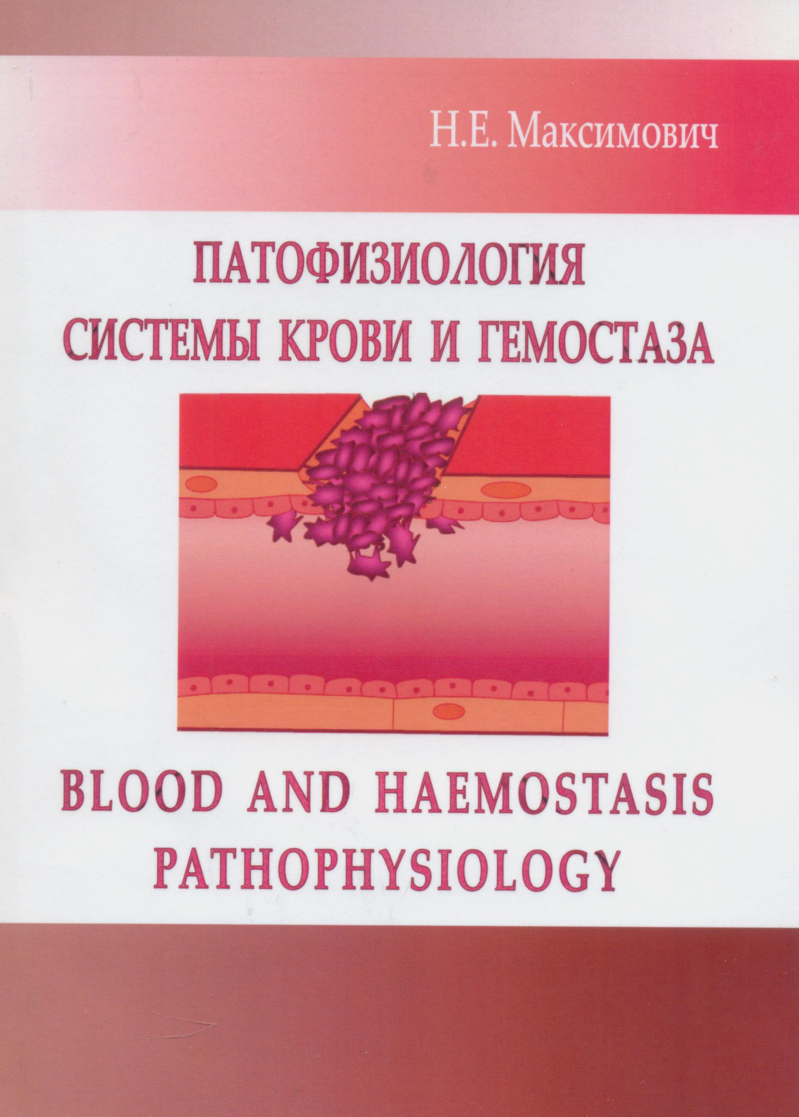
Manual «Blood and haemostasis pathophysiology» is intended to the Faculty for Foreign Students taught in English for successful studying the subject. It contains the information on the topics of the part of Pathophysiology «Blood and haemoslasis pathophysiology».

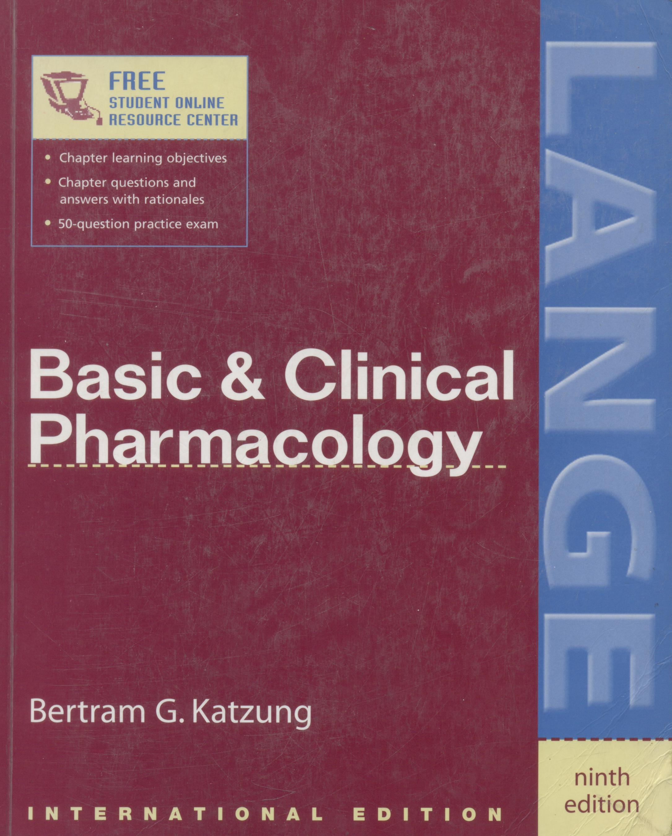
RECOGNIZED AS THE LEADING PHARMACOLOGY TEXT AMONG
STUDENTS AND PROFESSIONALS, BASIC & CLINICAL PHARMACOLOGY
OFFERS AN UNPARALLELED UNDERSTANDING OF BASIC PHARMACOLOGIC PRINCIPLES AND CLINICAL USE OF DRUGS.
- Authoritative, readable presentation of the scientific basis of pharmacology and its implications in clinical drug therapy
- Organized by drug groups and prototypes
- Rigorously updated throughout, including coverage of antiarrhythmic drugs, antidiabetic drugs, anthelmintics, antiviral drugs, and drugs used for gastrointestinal conditions
- New focus on important developments in pharmacology based on genetically modified mice ("knockout" and "knockin" mice)
- Mechanism of action and toxicities of traditional and newer drugs
- Treatment strategies and drugs of choice for all major diseases
- Numerous reader-friendly features such as special interest boxes, list of common preparations, and dosage information
- Unique, evidence-based chapters on drugs of abuse, special aspects of perinatal, pediatric, and geriatric pharmacology, and herbal medications and nutritional supplements
More than 500 illustrations and tables

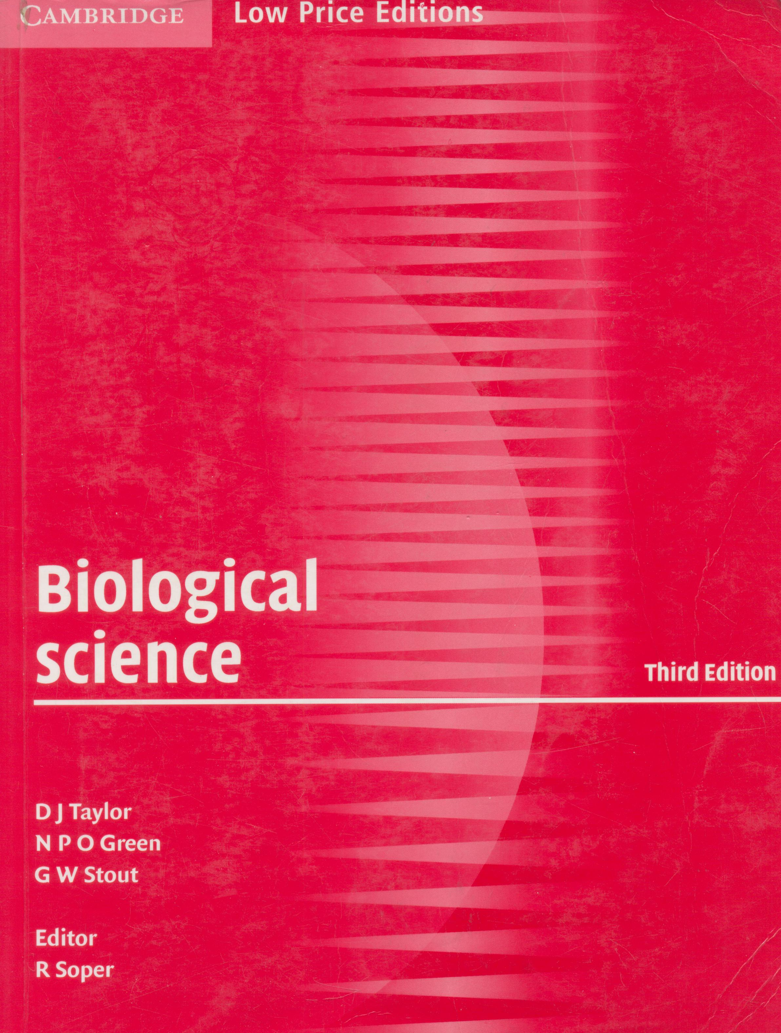
Cambridge University Press is part of the University of Cambridge. It is a charitable enterprise dedicated to printing and publishing for the advancement of knowledge throughout the world. In recognition of the fact that there are many parts of the world where students have difficulty in purchasing their own copies of the best international textbooks, Cambridge University Press is now publishing a series of Low Price Editions. These are reprints of internationally respected books from Cambridge University Press, specially printed and priced for the benefit of students and teachers in selected countries.
This is the new edition of the highly successful textbook Biological Science, a comprehensive and internationally established text for advanced students, including those following undergraduate courses. The text has been revised and updated, and provides comprehensive coverage of all the major areas of the biological sciences. New material has been added in the following fast-moving areas: human health and disease, microbiology and biotechnology, and the applications of genetics. Thought-provoking questions permeate the text to stimulate an enquiry approach to the subject, with answers in a commentary at the end of the book. In addition, a number of useful appendices are included covering biological chemistry, biological techniques and statistics. All the essential laboratory work required at this level is included in the form of selected and clearly presented practical investigations.

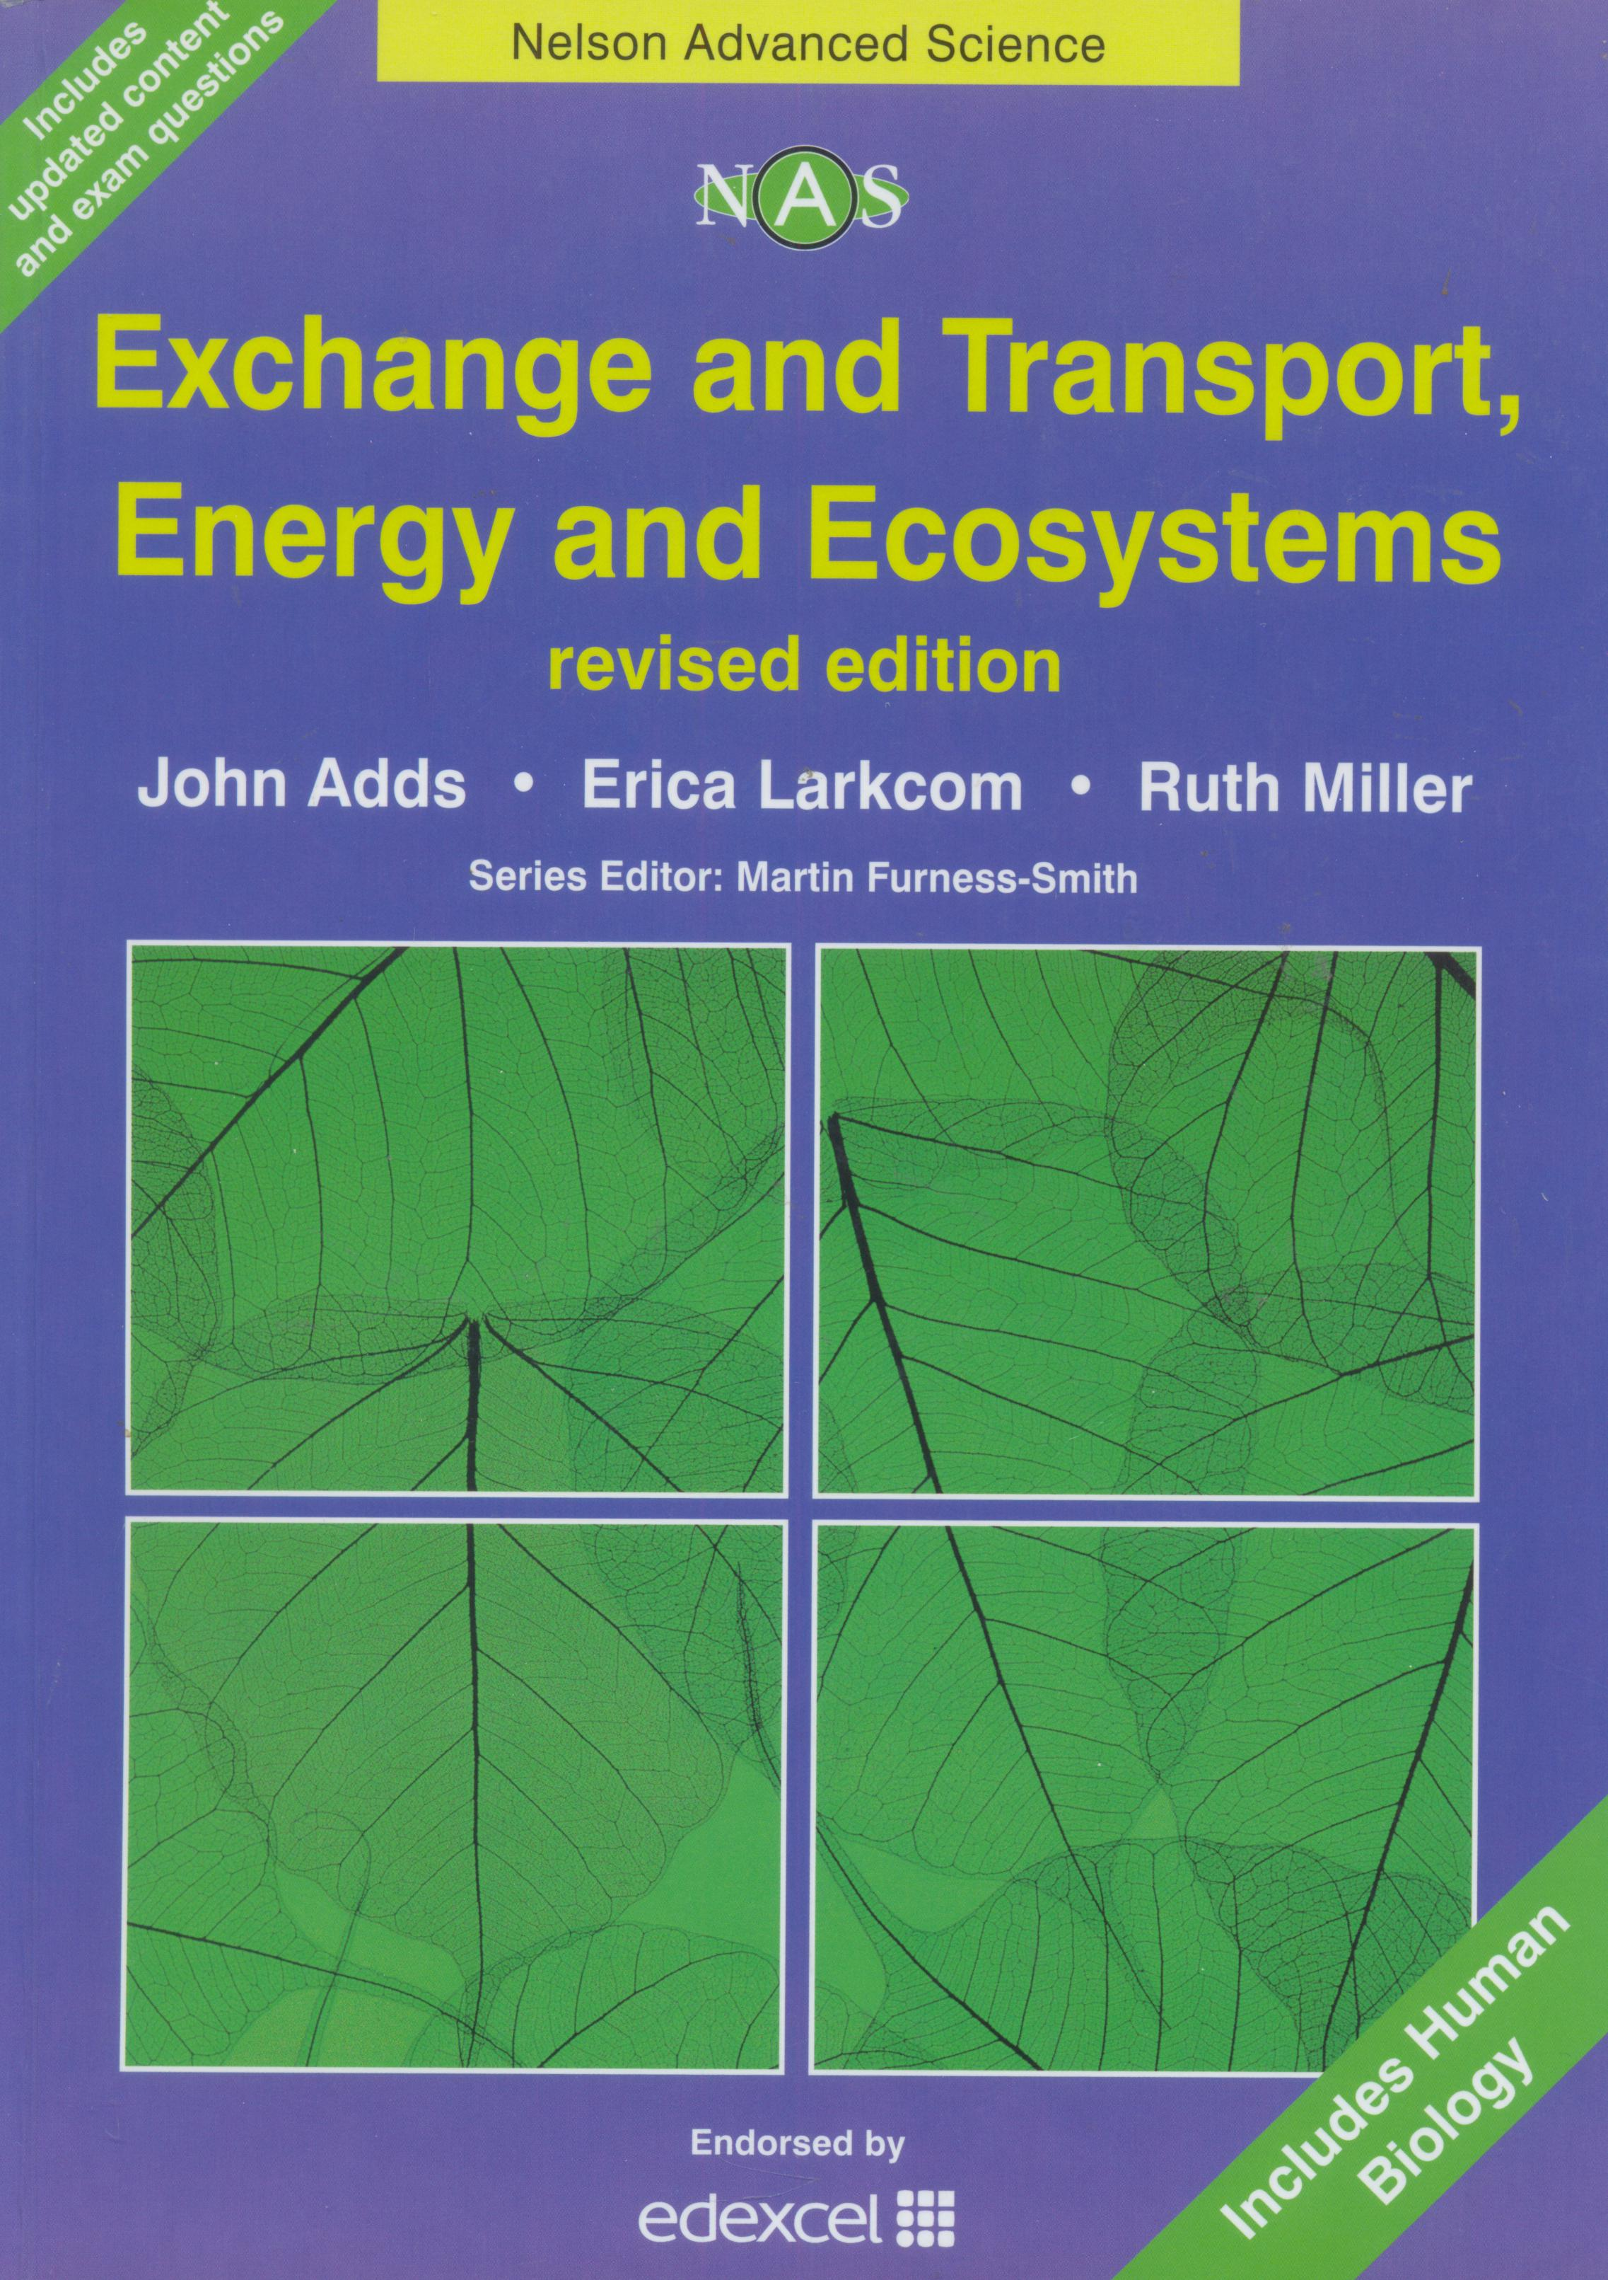
Nelson Advanced Science: Biology is a series of stimulating, high-quality, books for Advanced Subsidiary (AS) and Advanced (A) GCE Biology and Human Biology. Written by Senior Examiners and those involved closely with the AS and A GCE specification and its assessment, the books will help you achieve real success during your studies.
There are four books in the series, each containing updated content, and new exam questions. Every book is written for the Edexcel specification, and has been endorsed by Edexcel. The series is also a valuable resource for anyone following equivalent Biology and Human Biology courses.
Exchange and Transport, Energy and Ecosystems revised edition gives thorough coverage of Units Two and Three of the Edexcel specification, offering:
- An accessible and clear layout - making the information easily understandable
- Definition boxes - providing clear descriptions of key biological terms
- Extension material - information outside of the Edexcel specification that can help extend your knowledge of the topic and deepen your understanding
- Background information - information about a related topic or a reminder of material studied at a different level.
- Regular review questions - to stimulate your thinking whilst topics are being studied
- Practical investigations - with discussion questions to encourage analysis and evaluation
Practice assessment questions (with mark schemes) - to allow you to self- check during Unit Test preparation

