**Students’ Electronic Shelves**

**User guide**

1. **Open** [Students’](http://library.grsmu.by/view_vse_resursy.php?id=124) Electronic Shelves **on the Library website.**

**Choose faculty, year of studying, subject, textbook.**

The links lead to the full texts of books uploaded in the electronic catalogue of GrSMU Library, electronic library systems (“Student Advisor”, “Lan”), repositories of universities. **For reading, it is obligatory to log into one’s account!**

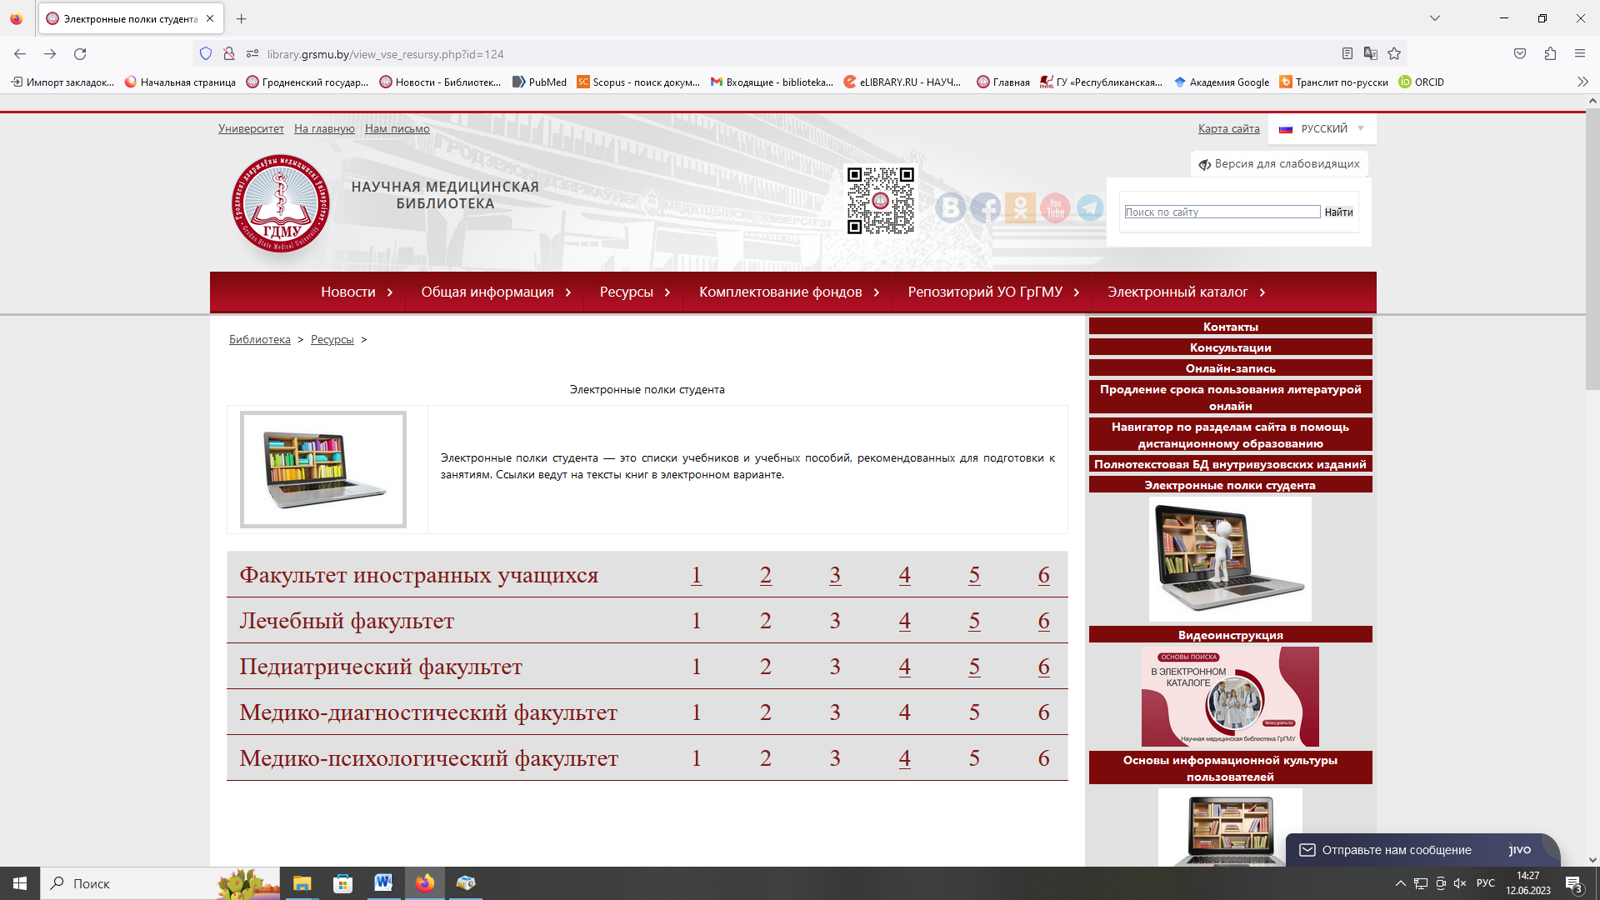

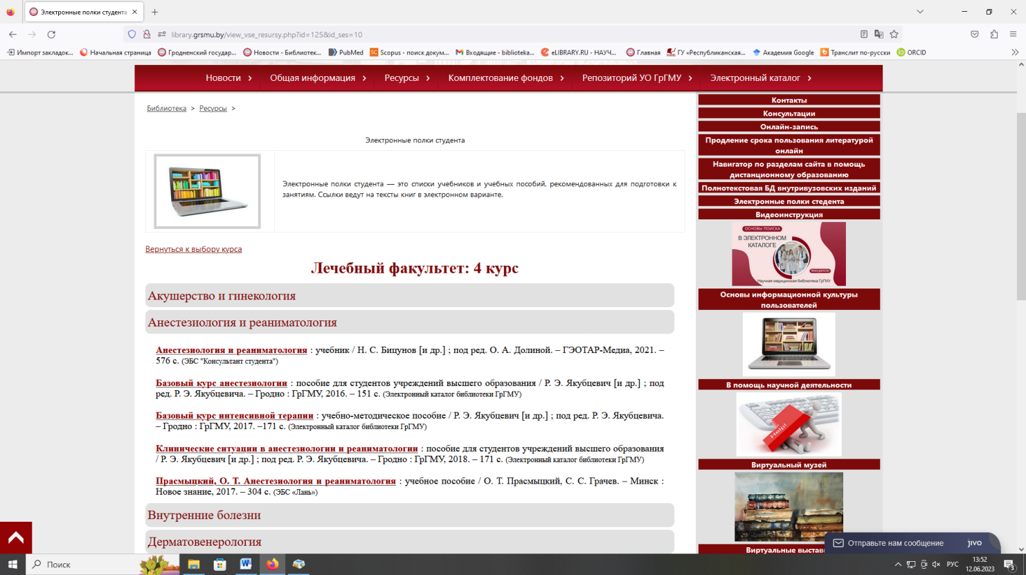

**Books from the Electronic Catalogue of GrSMU Library**

Пырочкин, В. М. [Клиническая электрокардиография](http://irbis.grsmu.by/cgi-bin/irbis64r_plus/cgiirbis_64_ft.exe?S21COLORTERMS=0&LNG=&Z21ID=GUEST&I21DBN=FULLTEXT_FULLTEXT&P21DBN=FULLTEXT&S21STN=1&S21REF=10&S21FMT=briefHTML_ft&S21CNR=5&C21COM=S&S21ALL=%3C.%3EI=332210%3C.%3E&USES21ALL=1) (Clinical electrocardiography) / В. М. Пырочкин, А. В. Пырочкин, Е. В. Мирончик. – Гродно : ГрГМУ, 2019. – 208 с. **(Electronic catalogue of GrSMU library)**

**Logging in is obligatory!** 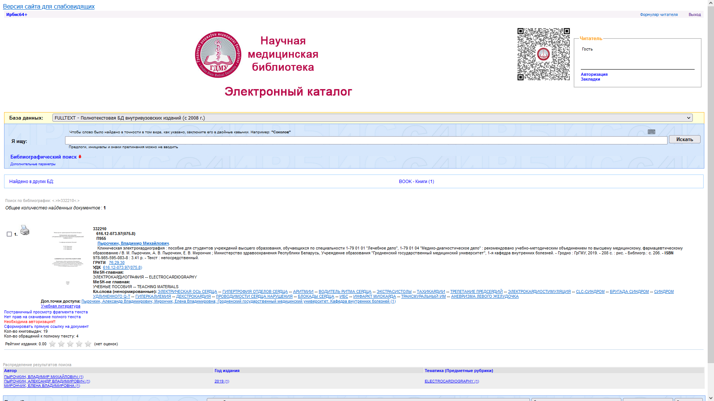

Login is one’s student ID number.

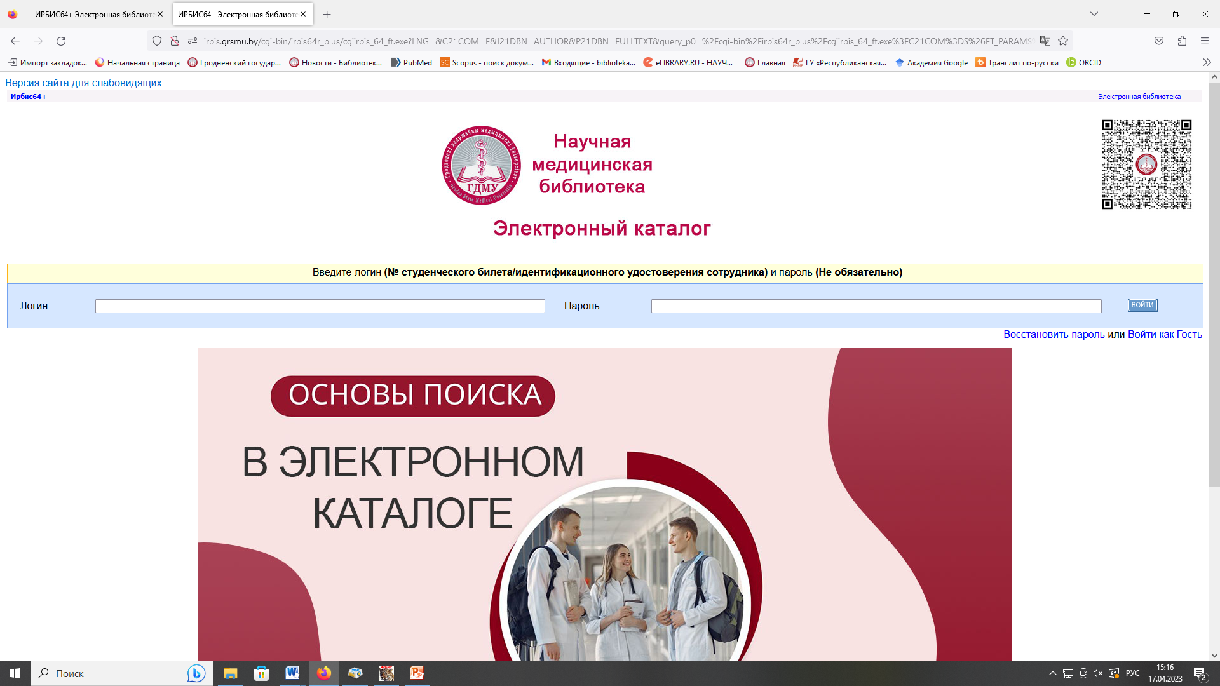

**After logging in, the book is available for downloading**

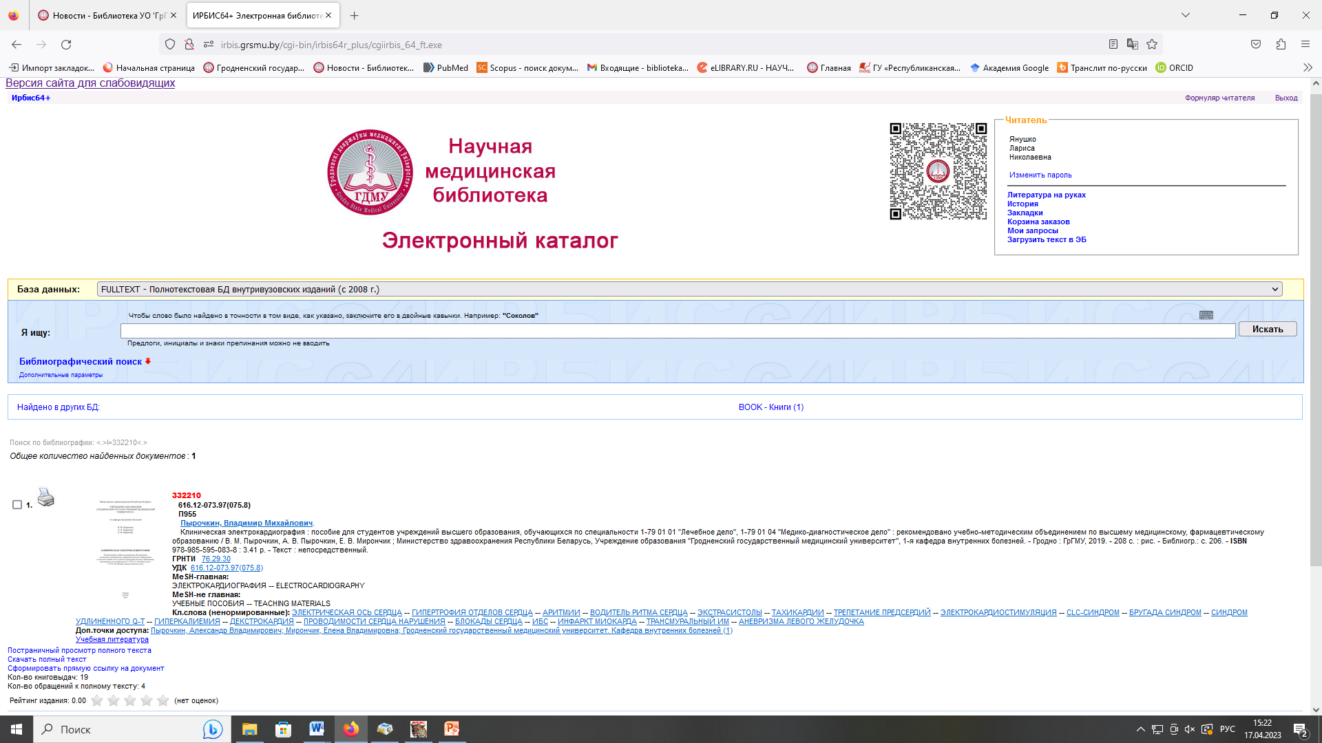

**Books from the ELS “Student Advisor”**

Околокулак, Е. С. [Анатомия человека](https://www.studentlibrary.ru/ru/book/ISBN9789850631664.html) / Е. С. Околокулак, Ф. Г. Гаджиева ; под ред. Е. С. Околокулака. – Минск : Вышэйшая школа, 2020. – 383 с. **(ЭБС "Консультант студента")**

**The registration on the website is obligatory. It is done on the University network**. After registration, books can be read and downloaded (a definite number of pages per day).

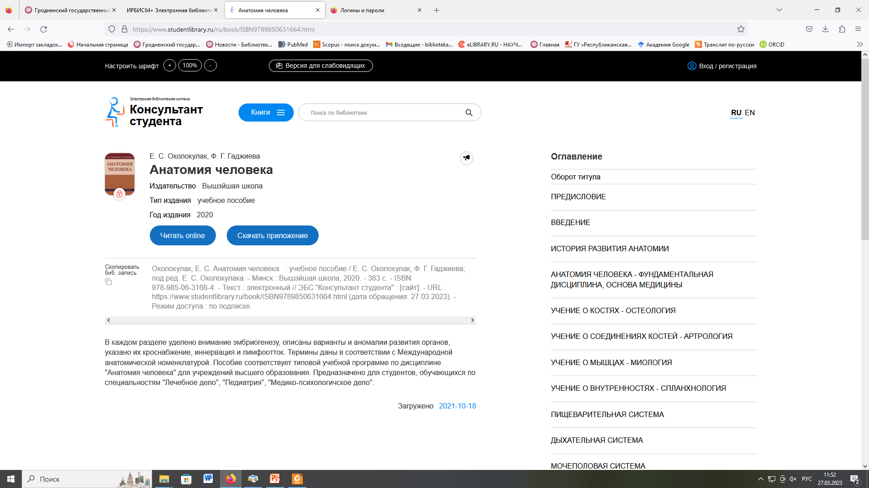

* Use the following options to save the text:

https://www.studentlibrary.ru/patrns/img/instruction/instr_52.jpgwhen reading, choose page view and scroll down to the end of the page and click on “view as PDF”.

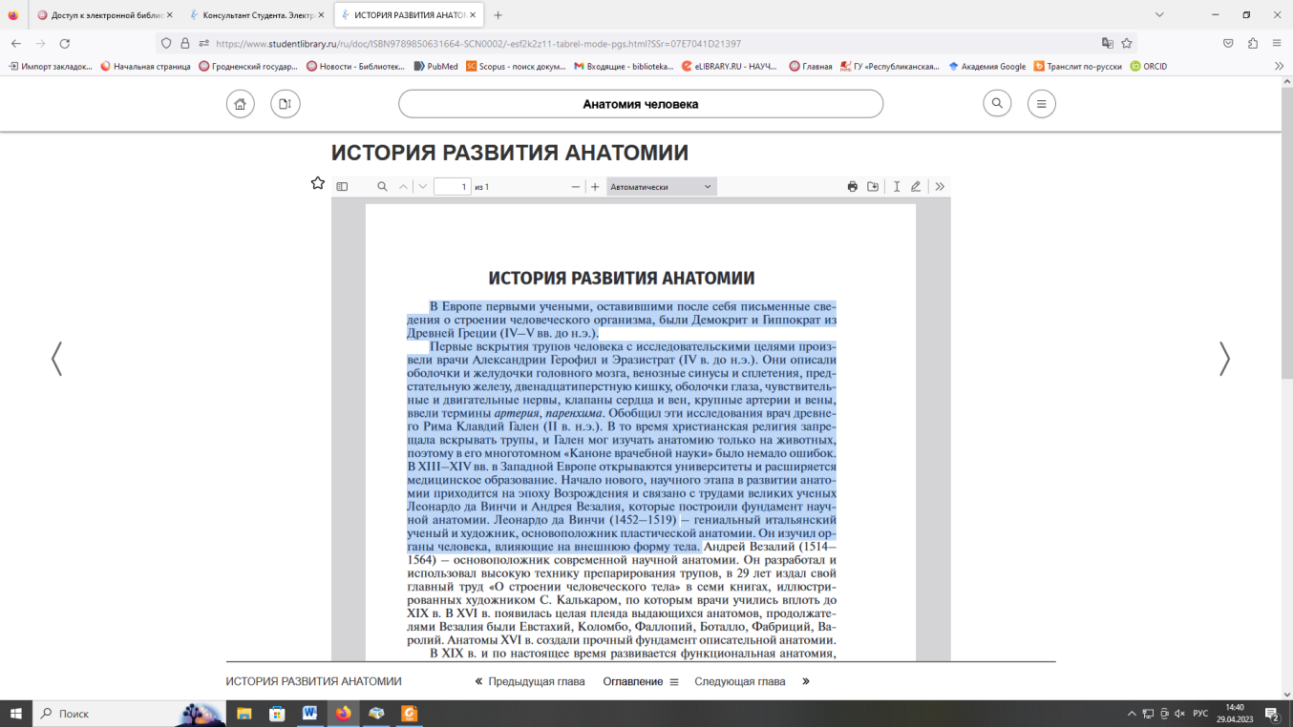

Next step is:

save or print the available number of pages (page by page)

copy the text

To exit the quote mode, go to another page.

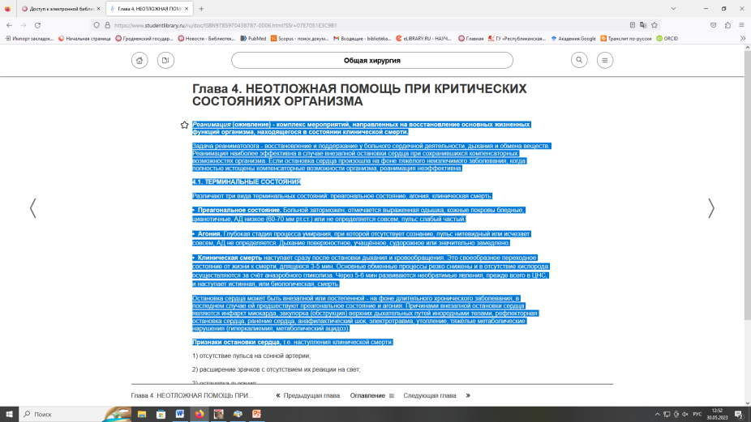

* If a book doesn’t have the option “view as PDF”, highlight and copy the text

**Books from ELS “Lan”**

[**Биоорганическая химия**](https://e.lanbook.com/book/181674): учебное пособие / О. Н. Ринейская, И. В. Романовский, Ф. Ф. Лахвич, С. В. Глинник. – Минск : Новое знание, 2022. – 280 с. **(ЭБС «Лань»)**

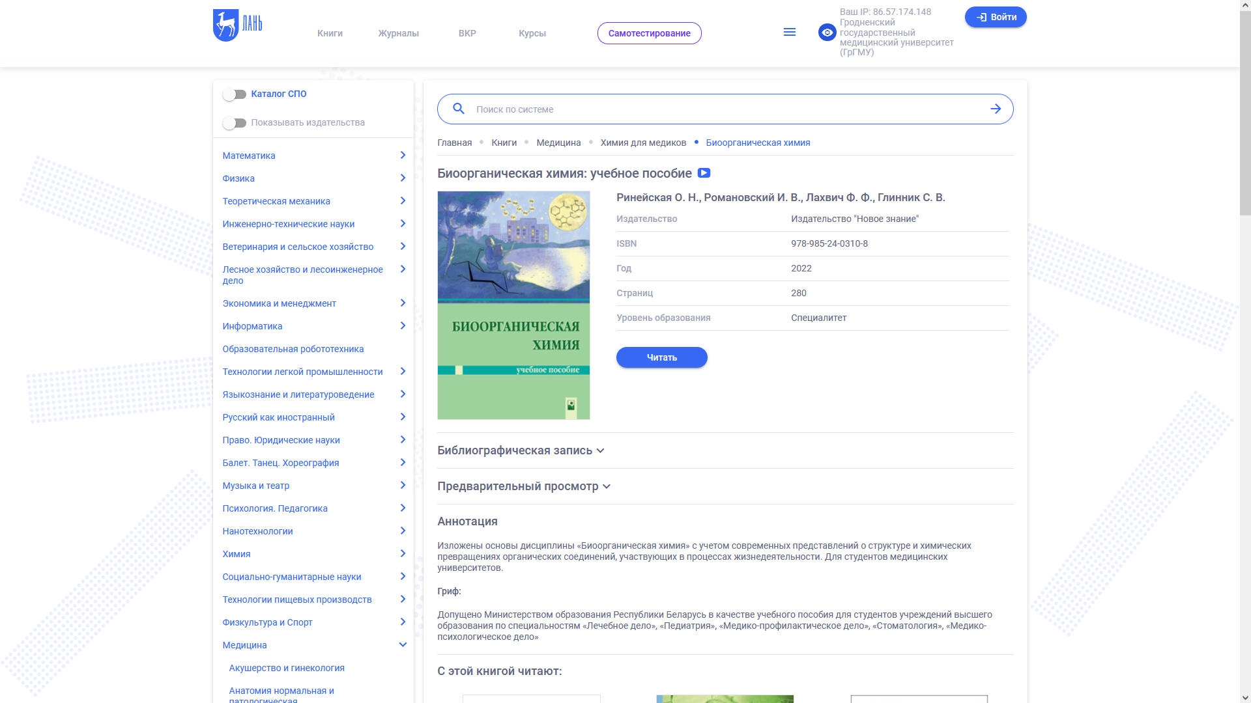**Registration is obligatory**.

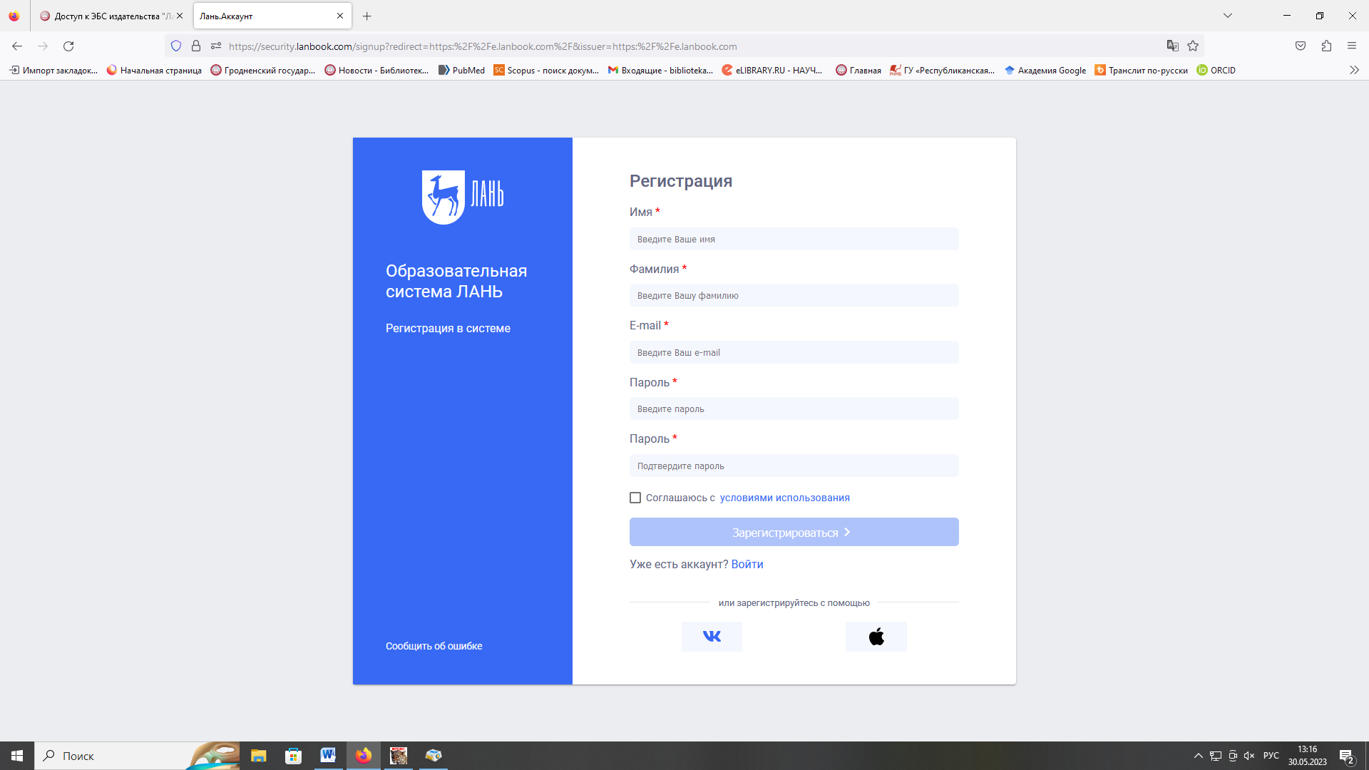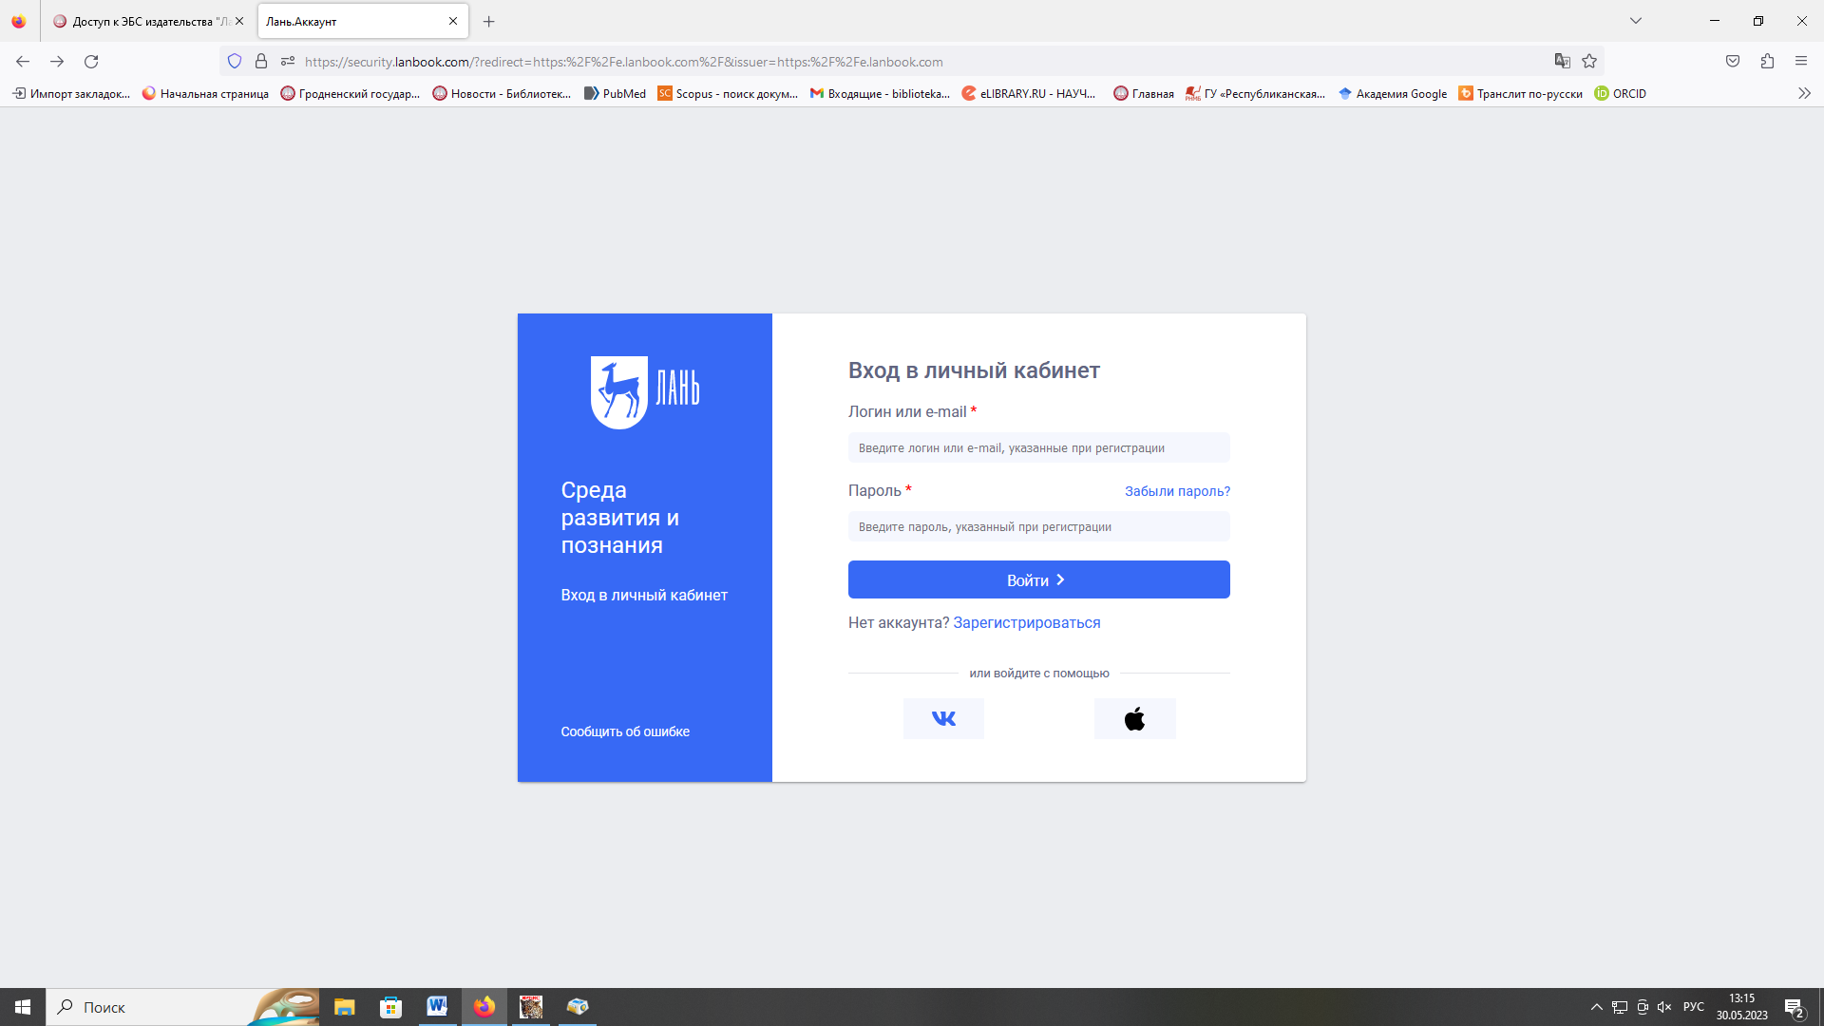

After logging in, books can be read and copied (a certain number of pages).

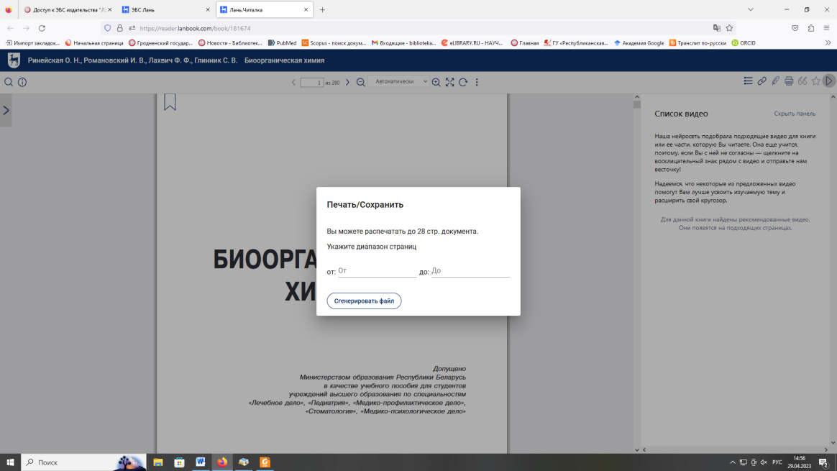To copy the text, click on the print icon and select the necessary pages.

**Books from the University Repository**

Буйневич, И. В. [Туберкулез = **Tuberculosis**](https://elib.gsmu.by/handle/GomSMU/6871) / И. В. Буйневич, С. В. Гопоняко. – Гомель : ГомГМУ, 2022. – 148 с. **(Репозиторий ГомГМУ)**

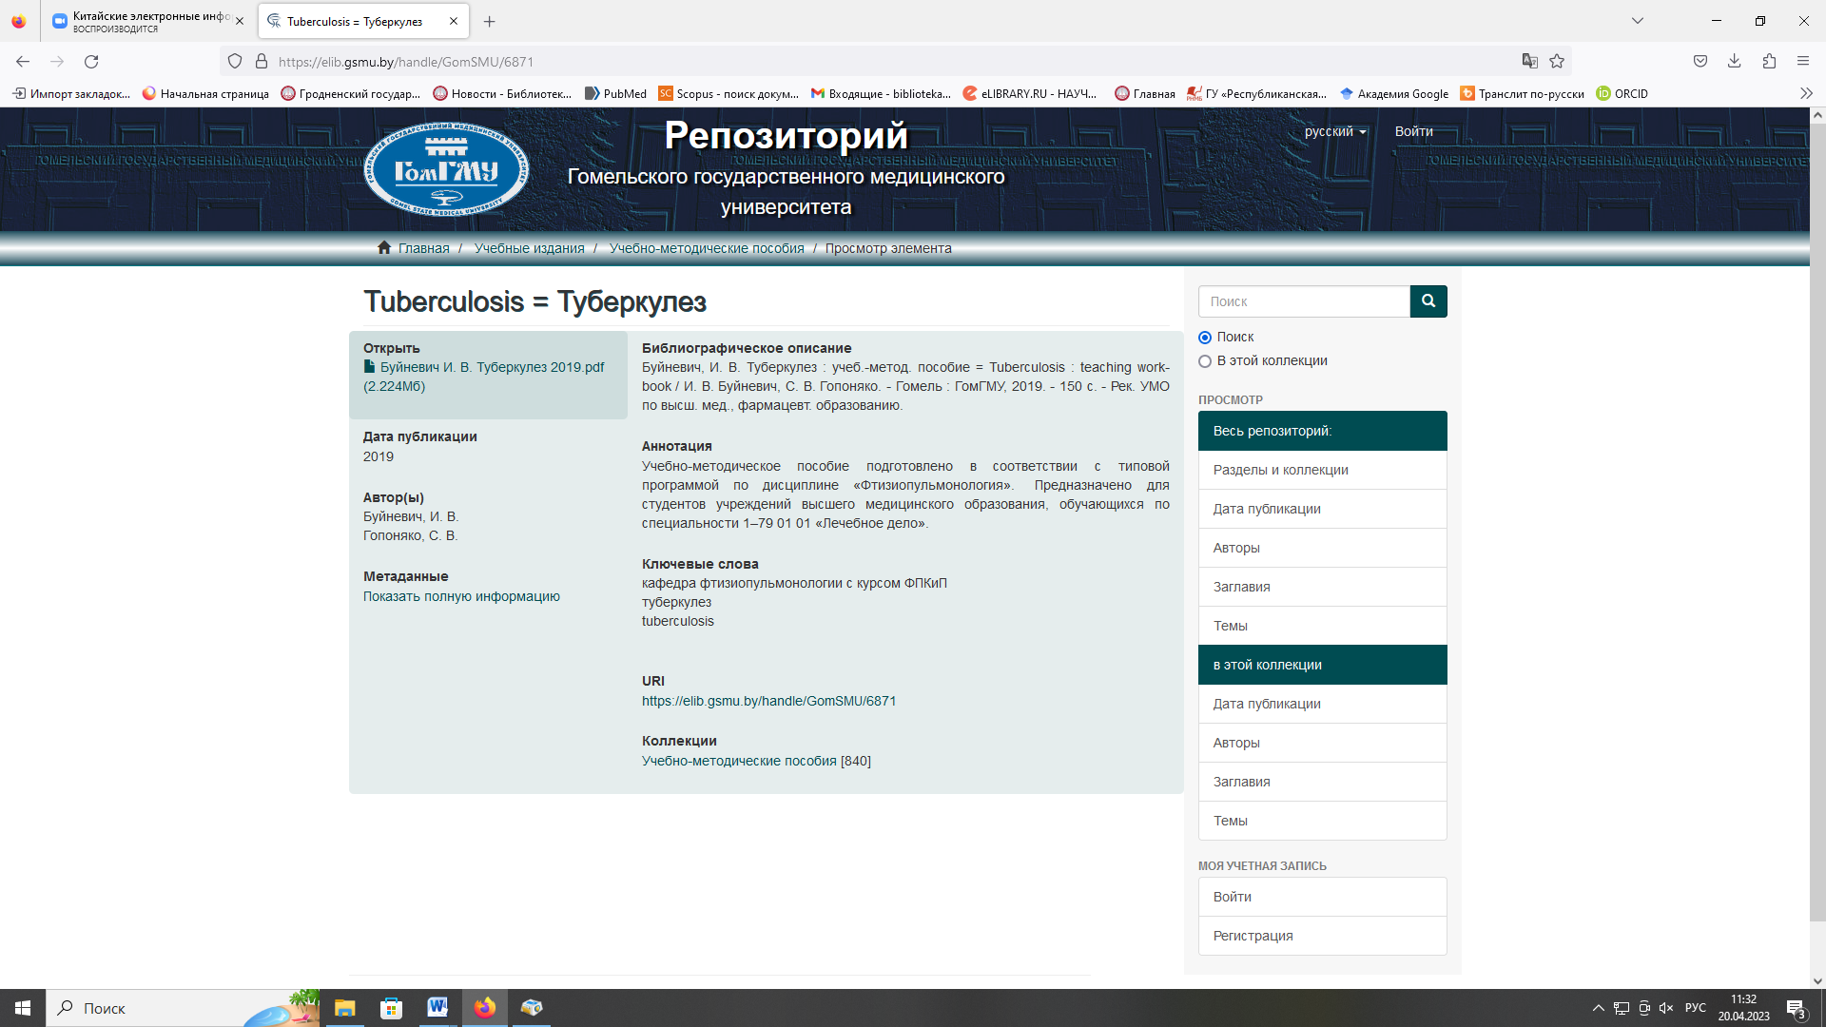

After following the link, it is possible to download the full text. These are open access books.